MASSACHUSETTS RURAL LETTER CARRIERS’ ASSOCIATION
SPRING STATE MEETING
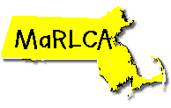
Fitchburg
May 6, 2018
Business Meeting
Sunday, May 6, 2018

8:30AM-3:00PM
Great Wolf Lodge
150 Great Wolf Drive
Fitchburg, Ma 01420

Lunch is at a cost of $10
For reservations please contact Dawn Makrinikolas at
508-838-3800 (leave message) or Dawn.Makrinikolas@NRLCA.org
National Officer Shirley Baffa
Resolution & Constitution Changes
Election Results
Engineering Study
District News

